VICTORIA JUNIOR COLLEGE
JC2 PRELIMINARY EXAMINATION P2 2024
H2 GEOGRAPHY PAPER 2 9173/02

MARK SCHEME
Section A

Qn |  | Answer | Marks
1 | (a) | With reference to Resource 1, suggest a suitable hypothesis and explain why it is suitable. | [3]
Award 1 mark for the hypothesis, which should mention the sites and compare variation in flood risk
Award 1 mark for a strength and a maximum of 1 additional mark for further development of each explanation.
No marks are awarded to the reasoning if the proposed hypothesis is not suitable.

Possible responses include:

Possible hypothesis
- Site 1 has the highest flood risk amongst the four sites [1]
- Flood risk is greater in the west of Edo City than the east of Edo City [1]
- Locations nearer to Arakawa River has a highest flood risk. [1]

Strength
- Clearly defined variable which is ‘flood risk’ [1] that is measurable using the questionnaire survey [1 additional mark]
- Suitable scale as the sites are all within 6km of each other [1] and they can travel to each site easily on each day to conduct 25 surveys at each site. [1 additional mark]
- It is possible to compare the flood risk between the sites using the questionnaire survey. [1]

AO1
1 | (b) | With reference to Resource 1, suggest reasons why the students chose to do fieldwork at these 4 sites. | [4]
Award 1 mark for a reason.
Award a maximum of 1additional mark for further development of each explanation.

Possible responses include:
- The 4 sites are located in places with different risk of flooding and the students can find out if the perception of people there matches the flood risk map. [1] Site 1 is located in an area that have higher risk of flooding, while Sites 2 and 3 are located in areas with lower risk of flooding, and Site 4 is located in an area with moderate risk of flooding. [1 additional mark]
- The 4 sites are spread across different parts of Edogawa City, and this will ensure that the data collected is more representative of the entire Edogawa city, thus allowing to collect more accurate and reliable data. [1] Site 1 is located on the west, while Site 2 is located in the central, and Sites 3 and 4 are located on the west of Edogawa City. [1 additional mark]
- The 4 sites are located at different rivers in Edogawa City. As each river has different discharge, the student can find out the fluvial flood risk of different rivers in Edogawa City. [1] Site 1 is located on the next to Arakawa River, while Site 2 is located next to Shin-Nakagawa River, and Sites 3 and 4 are located next to Edo River, with Site 4 being 2.5km downstream of Site 3 and may have a higher fluvial flood risk. [1 additional mark]

AO2
1 | (c) | Using Resource 2 and 3 only, suggest why it was not feasible to take river measurements at the chosen sites. | [5]
Award 1 mark for a reason and data from the resource.
Award 1 maximum of 1 additional mark for further development of each explanation.
Full marks are given only if resources are used.

Possible responses include:

- It was not feasible because were unable to enter the river as Resource 2 shows that there are fences lining the river and there are fences at the street level to prevent entry into the river. [1]
- It was not feasible because they might not have sought permission from the city government to conduct fieldwork investigations at the 4 sites. Resource 2 states that permits are needed for any water activities. This suggests that without the permit, the unable to enter the river to conduct their primary fieldwork. [1]
- It was not feasible because it was too risky for the students. Resource 3 shows that the width of each site was very long, so the students will not be able to wade through the river from bank to bank or stand upstream or downstream of the river to float the oranges down to measure velocity [1 additional mark] and may risk being washed away by the high river velocity. [1 additional mark]
- It was not feasible because they did not have suitable equipment to measure the width. The preamble states that students have a 50cm measuring tape and two 10m twine, it was close to impossible to the students to measure the actual river width. [1]
- It was not feasible because there are boats anchored on the opposite bank. The students would not be able to place a ranging pole there to measure river width or depth. [1] Furthermore, having boats there may also suggest that the river is deep. This is further supported by Resource 3 which shows that the depth at least 11m deep which is higher than the safe height of calf deep water, which also makes it risky for students to enter the river. [1]
- It was not feasible because the riverbank is adjacent to a road, which poses a safety risk to the students to access the river. [1]

AO2
1 | (d) | Describe the steps students could have taken to measure the river velocity with the given equipment. | [6]
Award 1 mark for each step.
Award a maximum of 1 additional mark for further development of each explanation.

Possible responses include:

First, students will need to find a straight stretch of river where there are no obstructions to the flow of water from trees or rocks [1] as any obstructions will hold back the orange and the velocity recorded will be lower than the actual velocity, making it inaccurate. [1] A straight stretch will ensure that the floating object will not be caught at any bends, making the data more accurate. It is also easier to measure the straight-line distance with the tape measure that they have. [1]

Second, students will place one ranging pole in the river to mark the starting point. They should anchor it upright, perpendicular to the river bed. Using the tape measure, measure 10 meters in the downstream direction and mark out the second location with another ranging pole, marking the end point. [1]

Third, students will place the orange 10cm behind the first ranging pole/start line. When the orange flows past the first ranging pole/start point, start the stop watch. When the orange flows past the second ranging pole/end point, stop the stop watch. This will mark the time taken for the orange to travel 10m. [1]

Fourth, students should repeat the velocity readings 3 times (because the preamble stated that this was part of their plan) then find the average. This is done by flowing the orange 2 more times down the same 10m stretch. [1]

Calculation:
- Velocity is calculated by dividing the distance in meters by the time taken to travel in seconds. Average is calculated by adding the 3 recorded velocities and dividing it by 3. [max 1 because the question is on measurement rather than calculation]

AO1

1 | (e) | Using Resource 4, explain the strengths and weaknesses in their questionnaire survey. | [6]
Award 1 mark for each explanation of strength or a weakness.
Award a maximum of 1 additional mark for further development of each explanation.

Note: Only about the survey questions, not about the time or sampling.

Strengths

- It has both open-ended and close-ended questions. + Support with data of each. This would allow them to collect both quantitative and qualitative data. [1] The open-ended question allows participants to efficiently answer the survey with the given choices [1], and the students can also quickly tabulate the quantitative data based on the pre-defined choices. [1]
- It is concise and can be completed in 5 minutes. This will allow more efficient data collection as they can get 25 people within 2h at each site. [1]
- Valid questions that can be used to test the hypothesis. [1] Q2, 3, and 4 investigates into the people’s perception of floods, while Q5 investigates into the city’s flood strategies while Q6 investigates the correlation between the existing flood strategies and their perception of flood. [1]
- The design is polite and clearly states their investigation. Understanding the purpose of the investigations make the respondents are more willing to answer truthfully. This makes the data collected more accurate.
- Q1 asks the length of stay in the area and can indicate how familiar the resident is to the flood situation in the area. When a person stays long enough in the area, they can give more insights into past flood events or the change in flood mitigation strategies.

Limitation

- There are many technical jargons in Q5 such as “flood proofing” and “floodplain zoning” that may not be well understood by the respondent. [1] They may guess their meanings to complete the survey, and this may lead to inaccurate data collected. [1]

- There are subjective terms are used in Q3 such as “low, medium, high” flood risk. [1] These terms have no quantitative value and can be understood differently by different people based on their personal characteristics. [1]

- The entire survey is in English, but the respondents are likely to be Japanese. The language barrier may cause respondents to misunderstand the questions or cause their responses to be poorly understood by the students. This will result in inaccurate data.

AO2

1 | (f) | Using a suitable data representation method, present the results to Question 3 in the questionnaire survey shown in Resource 5, and justify your choice. | [6]
Award 1 mark each of title, axis, legend, up to a total of 2 marks.
Award up to 2 marks for accuracy
Award up to 2 marks for justification.

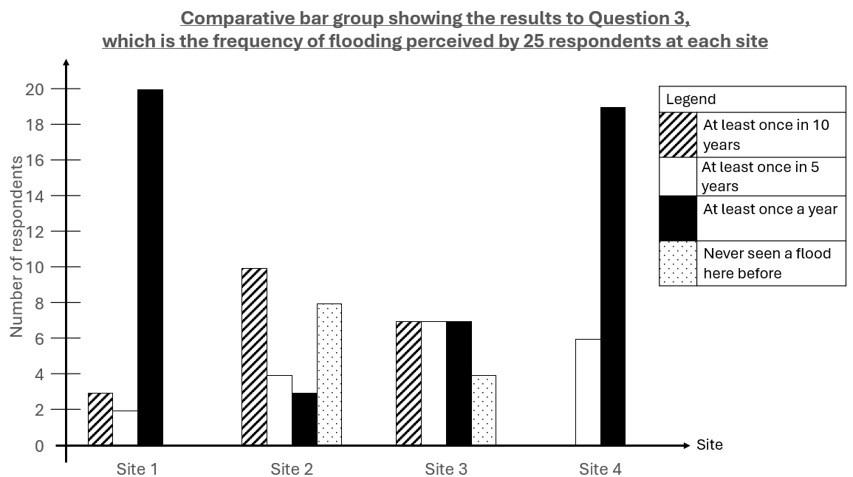

Justification [max 2m]
- A comparative bar graph helps to present large data into 1 graph sharing the same axis. [1]
- This allows easy comparison of data sets across 4 sites. [1]
- Bar graph is used for discrete data. [1]

Alternative graphs:

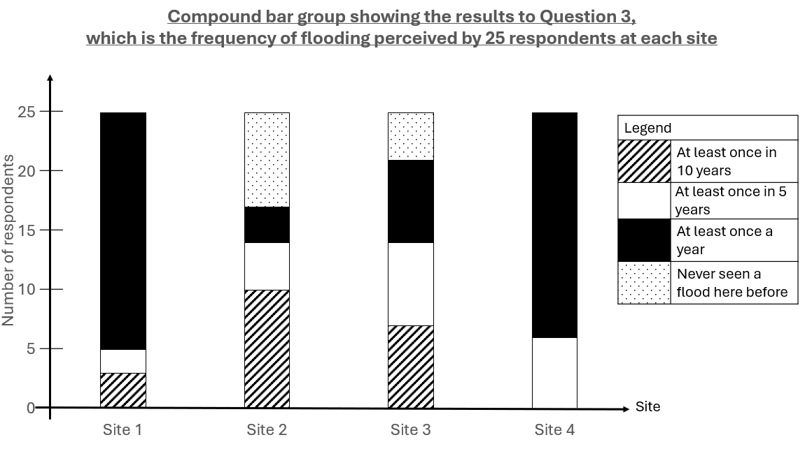

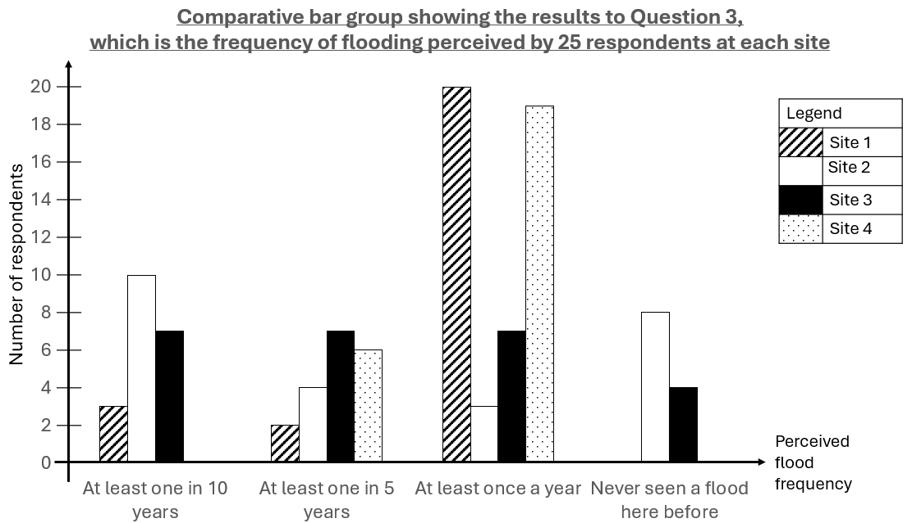

AO2
1 | (g) | The students concluded that Site 1 has the highest flood risk. With reference to all resources, evaluate the validity of their conclusion. | [10]
Overall, their conclusion is valid to a small extent. Flood risk = Hazard x Vulnerability x Exposure

Valid because:

Data supports it:
- Site 1 has the highest discharge amongst the 4 sites. Resource 3 shows that discharge is 1950m³/s at Site 1, 157.5 m³/s at Site 2, 275 m³/s at Site 3 and 330m³/s at Site 4. The higher the discharge, the higher chance of the river exceeding the bankfull capacity. Higher hazard of flood
- Resource 1 shows that Site 1 is located in an area with the highest flood risk compared to Sites 2, 3, and 4. Most of the evacuation facility only allow 3rd floor to be used, indicating that the lower floors tend to be flooded. In addition, there is larger concentration of wooden buildings that are at risk of collapse due to the rapid flow of water. Higher exposure to flood
- Resource 5 shows an overwhelming majority of 80% of the respondents said that Site 1 floods at least once a year. This is higher than all other sites. Higher likelihood of flooding, higher hazard
- When student corroborate/triangulate their findings from primary and secondary data does indicate that Site 1 is has the highest risk of flooding.

Data collection is accurate, reliable or valid:
- Credible source: Resource 1 is from the city government to warn people of the flood risk. The data would be supported by years of statistical data and thus the source is credible hence reliable and accurate.
- Non-biased and reliable data: Students used “systematic sampling to identify the sample population” and this means that they selected respondents based on a regular interval, such as every 5th person that walks by. This ensures that the is no biasness in selecting people. In addition, the students “ensured that there was a mix of people from different age groups and genders” which suggest that the population is diverse and more representative of the population in Edogawa City. This makes the data more accurate and reliable.
- [Can write if this has not been written earlier in Q1f] The questions are valid and can be used to prove that Site 1 is more at risk of flooding. Q2, 3, and 4 investigates into the people’s perception of floods, while Q5 investigates into the city’s flood strategies while Q6 investigates the correlation between the existing flood strategies and their perception of flood. [1]

Not valid because:

Data collected does not support it:
- Resource 5 shows that 3/25 people said that site 1 has low frequency of flooding once in 10 years, but no one in Site 4 said so. This suggest that the likelihood of flooding at Site 4 might still be higher than Site 1.

Data collection is not accurate, reliable or valid:
- Note: Underrepresentation of people in the schooling and working age due to the 2-4pm timing is not accepted because the students eventually got a spread of people from different age groups
- Short time frame compared to the whole year: The students only conducted the GI in June, and this is not representative of the flood risk throughout the year. For example, a recent flood event in other months can remind people of their exposure and vulnerability to floods more vividly, thus increasing their sense of flood risk.
- Small sample size: Students only interviewed 25 people at each site, and a total of 100 people. Since Edogawa City has a population of more than 695 000 people, the sample population is less than 0.01% of the total population and that is not representative of the total population of Edogawa City, making the data unreliable and inaccurate.
- [Can write if this has not been written earlier in Q1f] Language barrier: The data from the survey in Resource 4 may not be accurate as it was conducted in English when most of the respondents would be more familiar with Japanese. The respondents may misunderstand the questions or their responses to be poorly understood by the students. This will result in inaccurate data.
- Can write if this has not been written earlier in Q1f] Technical jargons inaccurate data

Missing data:
- Even though Resource 3 shows that Site 1 has the highest discharge, it does not indicate its bankful capacity. Without knowing the bankfull capacity, the students cannot know if there is fluvial flood.
- Frequency alone cannot indicate flood risk. Students needs to know the land value and economic and social losses from past floods at all 4 sites. Higher land value, economic and social losses can indicate the higher exposure to floods.
- Being able to calculate the discharge alone cannot indicate flood risk. Students also need to know the infiltration capacity and if it rained in the past week to know if the antecedent soil moisture is high. The lower the IC, more saturated the soil, the higher the proportion of rainfall flowing as overland flow and the faster rise in river discharge and the higher the flood risk.

Bankfull = when the bank is full, and the water level is at the top of its banks so any further rise in dischage would result in water moving into the flood plain.
Bankfull discharge = the discharge held in the river channel when the river has reached its maximum capacity. It is flow at which water just fills a channel without overtopping the banks.
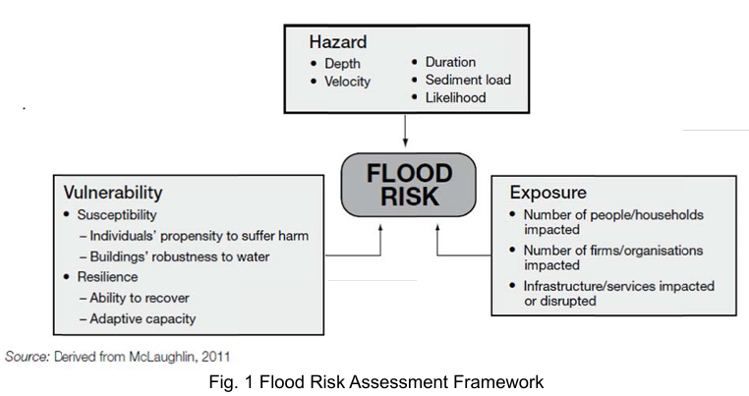

AO3

Levels marked using Generic Level Descriptors for H2 fieldwork evaluative questions

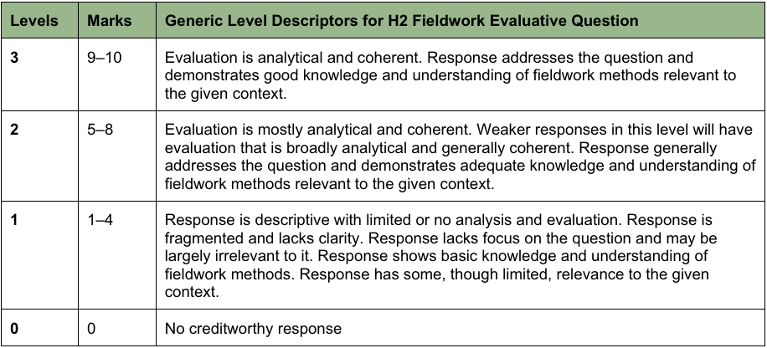

Section B
Qn | Answer | Marks
2a | With reference to Resource 6, describe the distribution of the world’s cities based on their liveability.  Award 1 mark for each relevant description. Award 1 additional mark for further development of each description, where applicable.  Possible points:  - Most the world’s most liveable cities with the highest liveability index of 90-100 are found in North America, Europe and Australia. [1] This includes the world’s most liveable city of Vienna. [1]  - However, there are also three cities with the highest liveability index in Asia – two in Japan and one being Singapore. [1]  - Most the world’s least liveable cities with the lowest liveability index of 40-60 or less than 40 are found in Africa, Asia and the Middle East. [1] This includes the world’s least liveable city of Damascus. [1]  AO2 | 4
2b | Explain what makes a city liveable.  Award 1 mark for each relevant point. Award 1 additional mark for further development of each point, where applicable. Students should describe at least two of the three aspects of liveability to attain the full mark.  - Cities are considered liveable when they can satisfy the physical and psychological needs and wants of its residents. [1]  - Liveable cities generally have the following characteristics:  - Economic resilient and vibrancy which allows them to generate employment and wealth for their residents. [1] They can do so by remaining competitive and open to the global economy, and by developing a broad base of economic sectors. [1]  - Environmental sustainability such as through minimising pollution through proper waste management and the use of clean energy. [1] This provides a more pleasant environment for their residents, thus improving their quality of life. [1]  - Socio-economic equality where all residents have access to affordable transportation, education and health services to meet their daily needs. [1] This is opposed to cities where socio-economic inequality is stark and only the affluent benefit from urbanisation. [1]  AO1 | 4
2c | Describe the strengths and limitations of tools such as the City Liveability Index in measuring urban liveability.  Award 1 mark for each relevant description. Award 1 additional mark for further development of each description, where applicable. Students should describe a minimum of one strength and one limitation.  Strengths:  - Allows for benchmarking and comparison between cities based on a common set of indicators. [1] The common set of indicators would also allow cities to learn from others who are doing better. [1]  - If carried out repeatedly, cities will be able to measure their own progress year on year towards greater urban livability. [1] This will allow local authorities to assess the effectiveness of any plans or policies they have implemented to improve urban livability. [1]  Limitations:  - Not all cities in the world are ranked, e.g. City Livability Index only ranks 173 cities worldwide. [1] This limits its ability to give a comprehensive picture of urban livability across all cities worldwide. [1]  - Depending on the set of indicators used, the tool may not be useful to all cities who are at different stages of development. [1] For example, cities that are less developed may benefit more from indicators that measure their progress on the brown agenda rather than the green agenda when it comes to environmental aspect of livability. [1]  AO1 | 6
2d | Explain how anthropogenic factors have contributed to contemporary climate change.  Award 1 mark for each relevant point. Award 1 additional mark for further development of each point, where applicable.  - The burning of fossil fuels due to urbanization and industrial activity has led to more greenhouse gas emissions. [1] Fossil fuels contain carbon from plants and animals that lived millions of years ago. The burning of fossil fuels releases these geological carbon stores of carbon rapidly into the atmospheric carbon store. [1] As CO₂ is a greenhouse gas that traps outgoing longwave radiation, it warms the atmosphere, leading to the enhanced greenhouse effect. [1]  - Deforestation has also led to the reduction of forests as carbon sinks. [1] When trees photosynthesize, they absorb CO₂ and store it in solid form in their branches and roots. However, deforestation leaves fewer trees available to sequester carbon. [1] In the extreme case when deforestation occurs through slash-and-burn techniques, large amounts of stored carbon are also released rapidly as CO₂ which traps heat, increasing global temperatures. [1]  AO1 | 6
2e | With reference to Resource 7 and 8, describe how Vienna has successfully improved urban liveability while also mitigating climate change.  Award 1 mark for each relevant description. Award 1 additional mark for further development of each description, where applicable. Students should refer to both resources to attain the full mark.  - Vienna has a well-developed public transport system. As seen in Resource B, there are many metro stations fanning out from the city centre up to a 15km radius. [1] This improves mobility and accessibility for the residents of Vienna, thus improving the social aspect of urban liveability as their daily commute is made more convenient. [1] At the same time, public transport is also a greener option as compared to private transport that helps to reduce the city’s overall carbon emissions, thus mitigating climate change. [1]  - Vienna has the presence of green spaces within the city. As seen in Resource B, larger green areas are found on the outskirts of the city, but there are also smaller green spaces closer to the city centre that are likely urban parks. [1] Green spaces help to provide fresh air, recreation spaces and an overall pleasant environment for urban dwellers, thus improving the environmental aspect of urban liveability. [1] At the same time, preserving green spaces protects trees that help to absorb CO_{2,} thus mitigating climate change. [1]  - Vienna has switched to cleaner energy sources. As seen in Resource C, climate protection areas were established where new buildings must be powered by renewable energy sources or highly efficient power plants. [1] The switch to cleaner energy reduces air pollution in Vienna, thus improving the quality of life for urban residents and minimises health problems that could be caused by poor air quality. [1] At the same time, renewable energy sources are more environmentally friendly and do not involve the burning of fossil fuels which can release large amounts of greenhouse gases, thus helping to mitigate climate change. [1]  AO2 | 6
2f | With reference to Resource 9, describe how Vienna’s urban design meets the needs of different social groups in Vienna.  Award 1 mark for each relevant description. Award 1 additional mark for further development of each description, where applicable. Students should refer to at least two social groups.  - Vienna’s urban design meets the needs of women. [1] As seen in the first photograph, wide pavements allow women with children to better navigate the streets with strollers. This allows women to make their way around the city with their children with greater safety and ease. [1]  - Vienna’s urban design meets the needs of the elderly/people with disabilities. [1] As seen in the second photograph, the installation of a lift caters to the elderly who may be too frail to climb long flights of stairs or individuals needing wheelchairs, thus improving their mobility and access to different parts of the city. [1]  AO2 | 4

Section C
3 | Evaluate the success of slum management strategies in helping cities in countries at lower levels of development achieve sustainable urban development.  Possible Approach:  Candidates could approach the question by making a judgement on whether slum management strategies (e.g. public housing, site and services scheme, upgrading of poor neighborhoods) have been successful in achieving the three dimensions of sustainable urban development (economic, social, environmental). They can do so through a consideration of two or more case studies. They could identify the contextual factors (e.g. level of community engagement and buy-in, political will) that allowed these strategies to be more successful in one city over another.  Levels marked using Generic Level Descriptors for 20m H2 essays.  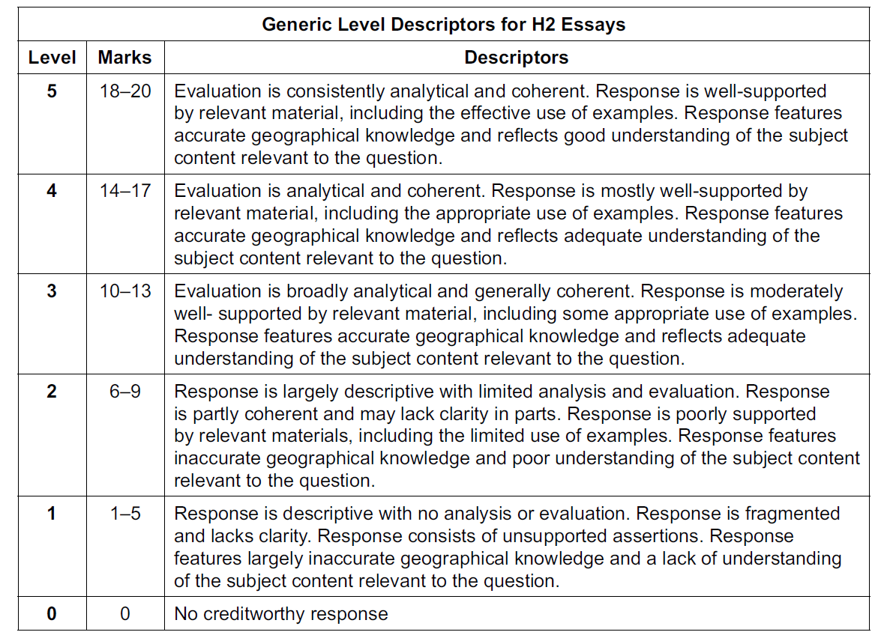  AO3 | 20
4 | ‘Sea level rise is the greatest threat posed by contemporary climate change.’ Evaluate this statement.  Possible Approach:  Candidates could approach the question by making a judgement on whether sea level rise is the greatest threat posed by contemporary climate change as opposed to other impacts (e.g. increased frequency of extreme weather events, reduced crop yields, increased vector borne diseases). Candidates should weigh the relative impact of sea level rise vs other threats (e.g. spatial/temporal scale, ability to mitigate its impacts) and identify contextual factors that would cause some places to be more vulnerable to their impacts (e.g. geographical location, level of development, adaptive capacity).  Levels marked using Generic Level Descriptors for 20m H2 essays.  AO3 | 20

 | AO1 (25m) | AO2 (35m) | AO3 (30m)
1(a) | 3
1(b) |  | 4
1(c) |  | 5
1(d) | 6
1(e) |  | 6
1(f) |  | 6
1(g) |  |  | 10
2(a) |  | 4
2(b) | 4
2(c) | 6
2(d) | 6
2(e) |  | 6
2(f) |  | 4
3 or 4 |  |  | 20
Total |  |  | 30

